Uzi Grip Order Form

Write desired quantity in blank.
__Black Grips ($28.95) __Green Grips ($28.95)
___Tan Grips ($28.95) __Sand Grips ($28.95)
___ Brown Grips ($28.95)
___ Complete set of all five colors ($125)
***Residents of Kentucky will be charged*** sales tax
***Shipping and Handling extra***
Payment by MasterCard or Visa
Credit Card #: _______________________
Expiration Date: __ /__
Billing Information
Name (exactly as it appears on credit card) ___________________________________
Address_____________________________
City________________________________
State ______ Zip Code _________________
Phone #: _________________________

Prestige Plastics Technology, Inc.
P.O. Box 97
Brooks, KY 40109
Phone (502) 955-6047
Fax (502) 955-9288

Prestige Plastics Technology Inc.
UZI Grips

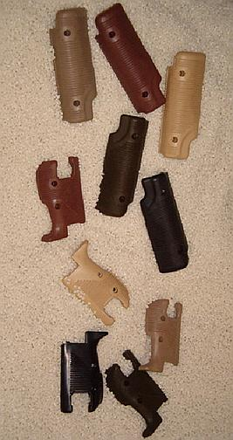
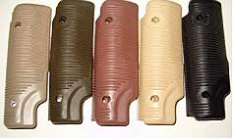
Colors from left to right are tan, olive, brown sand and black.

Fifty years ago the Uzi was first introduced to Israeli Special Forces. Eighteen years ago Prestige Plastics Technology began molding and selling Uzi grips to dealers and gun manufacturers. Today, those same Uzi grips are available to you, directly from the manufacturer.
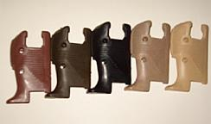
Hand grips and pistol grips are available in five solid colors: black, olive green, tan, sand and brown. The paintable grips are molded from Triax, a super strong ABS nylon alloy. Each grip features thick ridges ensuring a strong, reliable grip.
Vertical hold forward pistol grip.
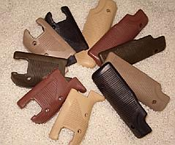
The grips are capable of withstanding extreme heat and cold and are virtually unbreakable. 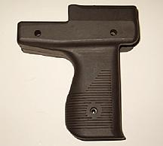

All grips come in the same size and fit all standard uzis.

Currently we only have the ability to manufacture a standard set of pistol grips and hand grips. However, if interest in the above vertical hold pistol grip is large enough, we can produce it.

