A few months ago, Milch Kalter, the affable head of Action Arms, the UZI importer for the United States, made a trip to the West Coast carrying with him two of his fully automatic firearms for the staff of Guns & Ammo to test. Because of legal restrictions, the G&A staff had never had the opportunity to wring out either of the fully automatic arms his company imports, the carbine and the Mini Uzi. The Mini Uzi, as its name implies, is a snub nosed, wire-stocked version of the standard Uzi SMG. In addition, it spews out 9mm slugs at an impressive 900 rounds per minute! This is a bit much for standard military issue, so this “burp” gun has become standard issue to those behind-the-scenes international government agencies that are seldom mentioned in everyday conversation. Agencies who demand the “bestest and the mostest” as their duties often require them to defend heads of states against terrorists.

Civilians, gun writers or not, seldom have the opportunity to fire real, live submachine guns. Thus, the G&A staff enjoyed having the opportunity to legally fire a gun that has drastically changed modern warfare. We also compared them to the standard semi-auto Uzi carbine that has caught the fancy of many military buffs in the United States. After sending many hundreds of full-auto rounds through both the full-sized SMG and the Mini Uzi, as well as a hatful of rounds through the semi-auto carbine, we were impressed! We found that the educated trigger finger could let off a single round - or a lethal six-to-ten-shot burst, ample proof of the versatility and controllability of this arm. One thing stood out after that day of feeding countless rounds through those Uzis - they were as reliable as a brick. They always worked with any ammunition we fed them. Hollow points, full metal jacket bullets, it didn't matter. We pulled the trigger and the guns went bang - every time! It was also that same day that Mitch verified for us the rumor we had been aware of for quite some time. Uzi, through Action Arms, was soon going to be introducing a pistol into this country as a companion piece for those shooters who liked the civilian-legal semi-automatic carbine and desired a handgun built along the same lines, and utilizing the same basic action as the bigger arm.

Well, now they've done it, and we had the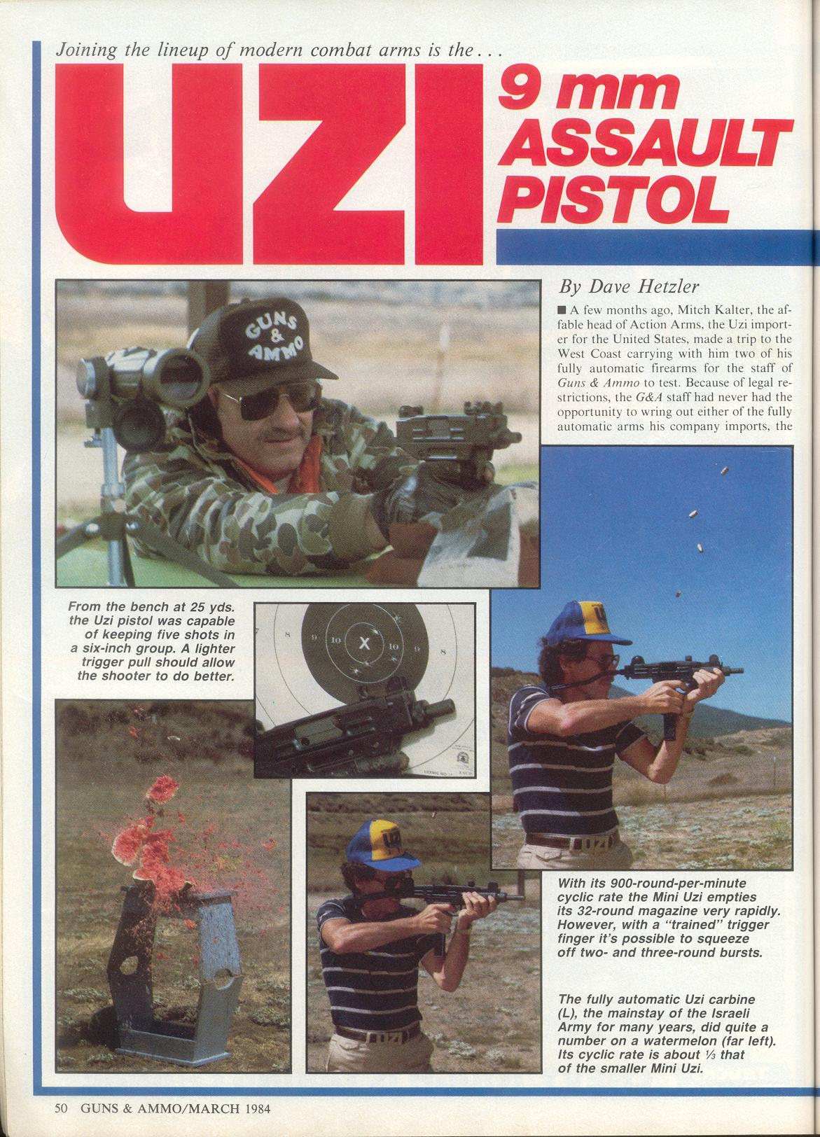 unique opportunity to put the first production model Uzi pistol, serial number 0001, through its paces. Our conclusion was that it was surprisingly accurate, for a two-fisted pistol, and, like its bigger, full-scale predecessors, reliable as a brick. We fed it Federal hollow point ammo, Samson FMJs - Israeli ammo imported by Action Arms Inc. - and it digested everything without a stutter. We didn't have the chance to try the pistol with lead bullets; no one on staff had any loaded up at the time, but there's no reason to think the pistol would be any different from the results we had during a previous test with the semi-auto carbine, and that particular arm had no trouble with handloads using cast bullets.

During our shooting tests, we also found the UZI pistol to group a smidgen tighter than we’d expected, although to be sure it isn’t a target pistol. Basically, what it is is a plinker, and that’s meant to say the pistol is a gun that’s fun to take out and blaze away with. That’s not all the new pistol is good for, of course; with its 20 round magazine full to the brim, it would make some serious kind of home defense arm.

Primarily, this pistol is nothing more than a blowback operated 9mm handgun. It utilizes a massive breechbolt and two heavy springs to overcome and tame the pressure generated by the 9mm Parabellum cartridge. Normally in a handgun, one would expect to see a pistol utilizing a locked breech, but the UZI isn’t a pistol that can be compared to other 9mm’s on the market. Since it’s not meant to be carried concealed, and its overall size is greater than most traditional pistols, the weight of the breechblock isn't a problem. Long before the breechblock has started rearward from the recoil the bullet has left the 4 1/2-inch barrel and breech pressure has dropped to zero. The breechblock’s rearward movement is halted by the recoil springs, backed up by a plastic or nylon buffer. Upon returning to battery another round is stripped from the magazine and fed into the chamber.

Being a semi-automatic, the trigger has to be released and pulled again to fire the newly chambered round. The pistol is available only in semi-auto, and in fact IMI has no plans to make it in any other configuration; this handgun is meant only for the civilian market.

The Uzi pistol shares much with its larger brothers. It has a grip safety that must be depressed by the firing hand before the gun will fire. It also has a standard safety that disengages the sear and blocks the trigger, located on the left side of the frame. It shares the same method of loading a new magazine into the magazine well as the full-size SMGs - the hands-to-hands style.

With this, the firing hand surrounds the pistol grip/magazine well, and by bringing the two hands together, the fully loaded magazine slips snugly into place.

Like its two older brethren, the new pistol is of modular design. The pistol can be stripped without the use of tools in less than a minute. It breaks down into four major modules; the breechbolt, pistol grip/fire control assembly, barrel and the frame. This modular design is found in most of today’s arms based on military guns in that allows for ease of repair in the field. Also, the average soldier doesn’t have to know a great deal about the internal workings of his arm - if something breaks, he only has to remove the faulty module and replace it with a new one.

Although not a target pistol, the Uzi has fully adjustable sights, the front for elevation and the rear for windage. Uzi supplies a sight adjusting tool for both and the sight itself is clever in operation. The post is four-sided, and each side has a white dot on it. Our test gun started out about eight inches high at 25 yards, and it took about ten turns to bring the sighting point down to the bullseye. The rear sight uses the same tool for windage corrections. The rear sight is a simple "U" notch with a white dot on each side of the "U". Lining all three dots up in a horizontal position - the two at the rear and the one of the front sight - gives you a quick and precise battle-sight picture.

Although fitted with adjustable sights, as we stated earlier, the gun isn't a target pistol. The primary reason we didn't get good groups could be traced to the trigger. Although the trigger broke with a fairly light seven-pound pull, it was plagued with creep and a great amount of overt ravel. It's a single stage military trigger, pure and simple, and any accuracy work suffers because of it. However, before you think you couldn't hit a bam if you were standing inside, let me assure you this isn't so. From a rest at 25 yards, both Howard French, editor of G&A, and I were able to fire six-inch, five-shot groups. When you think about it that isn't all bad. And when we set up a silhouette target at 21 feet, all 20 rounds from the magazine went into the “9” ring or better during rapid fire, again producing about a six-inch group. Most of the rounds were in a four-inch group inside the “10” ring in the best group shot, and that is very good combat accuracy.

The Uzi is no lightweight, weighing in at 56 ounces, and it certainly isn’t a small pistol with dimensions of 6 5/8 inches high, 1 ½ inches wide and 9.45 inches long. It is, however, more accurate than it has a right to be, and perhaps most of all it's an Uzi, a name steeped in history. The reliability of
he pistol should never be a problem.

Basically, it's the same design that has been proven time and time again in one of the roughest proving grounds in the world - the Middle Eastern deserts.

The Uzi pistol isn't inexpensive, costing $550, however very few have the heritage this pistol has. Although UZI is a new name when it comes to handguns, it should carve its own niche in the marketplace. It’s a natural for those who already own one of the semi-automatic carbines; it’s also a natural for the shooter/collector who wants to own a working bit of history. For more information see your local dealer or contact Action Arms, P.O. Box 9573, Philadelphia, PA 19124.

